Assignment 3 if for while conditions structure

Released Date: Oct 15th

Version 1.0

Format: Name the document in the combination of name、ID and No. of Assignment.

**Example: Ping Yi_23_Assignment1.doc**

**Email the document to “pingy@wxit.edu.cn” before Oct 18th.**

**Task 1** 4 LEDs are connected to Arduino Uno, try to use for cycle structure to make a 1s shift effect.

任务1 使用4个LED连接至Arduino Uno，尝试使用for循环结构，实现1s位移点亮的效果。

**You could use Tinker CAD or Proteus for the verifying.可使用在线工具Tinker CAD或Proteus进行仿真。**



**Fig 1 LED Shift Light**

|  |  |
| --- | --- |
|  | 1. // C++ code 2. // 3. int i**=**1**;** 4. void setup**()** 5. **{** 6. **for(**i**=**1**;**i**<**5**;**i**++){**    1. pinMode**(**i**,**OUTPUT**);** 7. **}** 8. **}** 9. void loop**()** 10. **{** 11. **for(**i**=**1**;**i**<**5**;**i**++){**     1. digitalWrite**(**i**,**HIGH**);**     2. delay**(**1000**);** 12. **}** 13. **for(**i**=**1**;**i**<**5**;**i**++){**     1. digitalWrite**(**i**,**LOW**);**     2. delay**(**1000**);** 14. **}** 15. **}** |

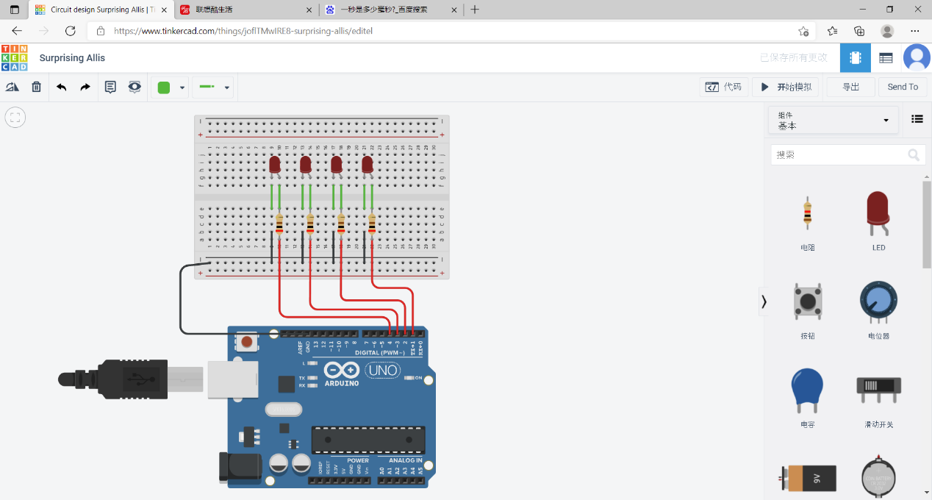

**Task 2** One LED and a POT are connected to Arduino, define a function named getVoltage to calculate the real time voltage of the POT, if the value is larger than 2.5V, then turn on the LED.

任务2 一个LED和一个电位器与Arduino Uno相连，定义一个函数名为getVoltage，用于计算POT段子的实时电压，若电压大于2.5V，则点亮LED。



Fig 2 LED Indicator

|  |
| --- |
| 1. // C++ code 2. // 3. int ledPin **=** 3**;** 4. int a0 **=** 0**;** 5. float val **=** 0**;** 6. void setup**()** 7. **{** 8. Serial**.**begin**(**9600**);** 9. **}** 10. void loop**()** 11. **{** 12. int sensorValue **=** analogRead**(**0**);** 13. float voltage**=** sensorValue **\*** **(**5.0 **/** 1023.0**);** 14. Serial**.**println**(**voltage**);** 15. delay**(**100**);** 16. **if(**voltage**>**2.5**){** 17. digitalWrite**(**3**,**HIGH**);** 18. **}else{** 19. digitalWrite**(**3**,**LOW**);** 20. **}** 21. **}** |